GENEROSITY
An intentional steward is called to be generous.
God never asks anything of us that he has not already given. Our generosity shows that we put God first in our lives, even before ourselves. Generosity means sharing all of your gifts,
especially the ones that mean the most to you, including your money.
CHURCH OFFERING
My/Our regular offering per ◻ week ◻ month
has been: $

My/Our regular offering per ◻ week ◻ month
will now be: $

Contact information
Print name:
Phone:
Email:
Signature:
Today’s date:

◻ I wish to receive information regarding online giving.
◻ I wish to receive information about including the parish in my Will or other Estate Planning.

Thank you for taking the time to reflect and respond! This card is an expression of your intention to give back to God a generous share of the gifts He has entrusted to your care. It is not legally binding. Your actual gift may change over time.
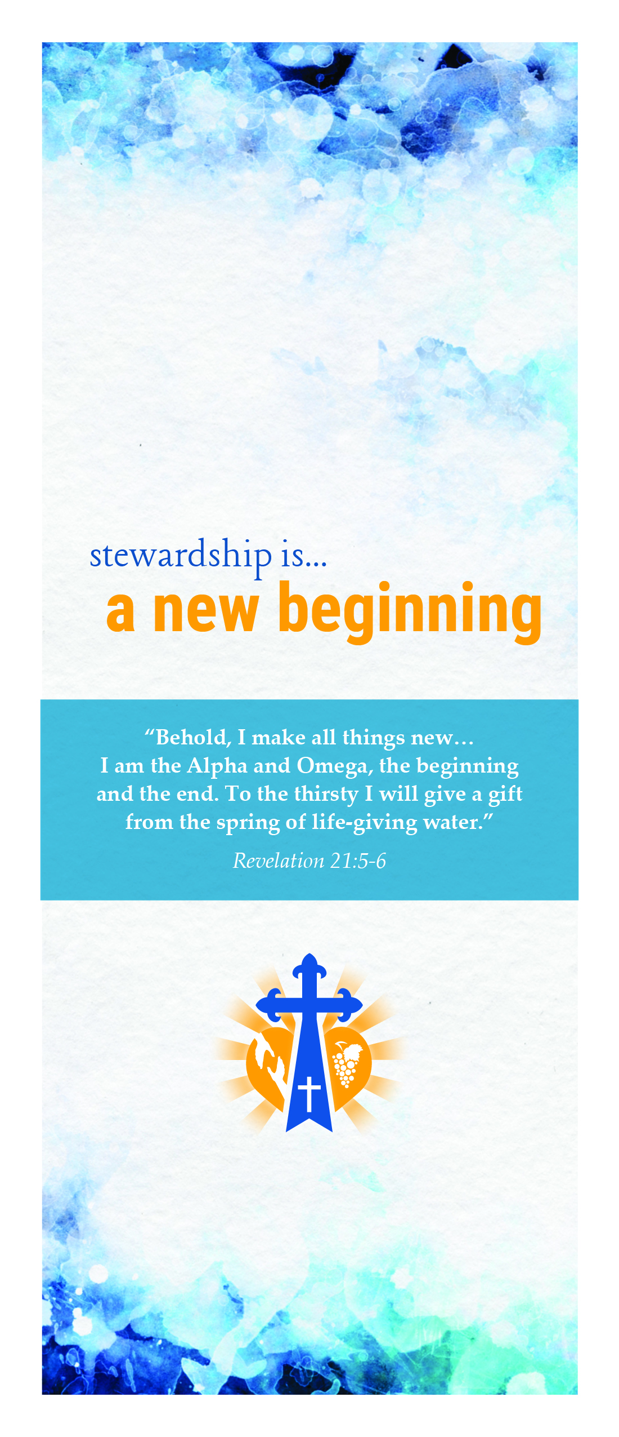
By completing this form, you will help turn
your good stewardship intentions into action.
By returning this covenant card to your parish,
you will help us with our budgeting and
planning for the next year.

All we do is rooted in the Word of God. Consider using one or more of the bible passages below in prayerfully reflecting on your own commitment:

“Rejoice always, pray without ceasing,
give thanks in all circumstances;
for this is the will of God in Christ Jesus
for you.”
1 Thessalonians 5:16-18

“Then I heard the voice of the Lord saying, ‘Whom shall I send? Who will go for us?’ ‘Here I am,’ I said, ‘send me!’”
Isaiah 6:8

“For where your treasure is,
there also will your heart be.”
Matthew 6:21

Your Story
Your story is important to us. Please use the space below to share with us how building a personal relationship with Jesus has changed your life,
and is reflected in your commitment to Stewardship. Or, scan and share your story digitally. Your personal witness is an important part of helping others embrace a God-centered life.
Response:

Renew Your Covenant with God
We are each made in the image of God, and
everything we have in life is a blessing from Him.
Today you are invited to deepen your relationship
with Him by joyfully participating more directly in
the life of the Church.
PRAYER
An intentional steward is rooted in prayer. We must
recognize the gifts given to us each new day,
and thank God daily for even the smallest blessings.
INTENTIONS
◻ Begin each day with a gratitude prayer
◻ Say Grace before each meal
◻ Pray the Rosary
◻ Make a Confession more frequently
◻ Attend Weekly Mass
◻ Attend Daily Mass
◻ Join Eucharistic Adoration frequently
PARTICIPATION
An intentional steward is committed to joyful
participation. You have a charism, a spiritual gift,
given to you by the Holy Spirit. Sharing your gift with
your parish is an important way to live your faith.
Please print the name of each household member
who is already active, or wishes to participate. Then
add the number code for each activity:
INTENTIONS
Name: First Last
I wish to become active in:
I am already active in:

Name: First Last
I wish to become active in:
I am already active in:

Name: First Last
I wish to become active in:
I am already active in:

MINISTRIES,
ORGANIZATIONS
and corresponding number codes
Liturgical Ministries
01 Choir/Cantor/Musicians
02 Special Occasion Choir
03 Children’s Choir/Teen Choir/Musicians
04 Funeral Choir
05 Eucharistic Minister
06 Eucharistic Minister to the Sick
07 Eucharistic Adoration
08 Greeter/Hospitality
09 Lector
10 Server
11 Usher
12 Youth Lector
13 Bereavement Outreach
14 Offertory Procession
15 Liturgy Committee
16 Church Cleaning
17 Church Decorating/Art & Environment
18 Liturgy Planning Committee
Catechetical Ministries
19 Parish Day School ñ Volunteer
20 Parish Board of Education
21 Sunday Pre-School
22 Marriage Prep ñ Couples
23 RCIA ñ Convert Classes
Teachers
24 Parish School of Religion ñ PSR
25 Sunday Pre-School
26 Liturgy of The Word for Children
Youth Programs
27 Jr.-Sr. High Youth Ministry
28 Athletic Association
29 Scouting Programs (Boys/Girls)
Leadership Ministries
30 Stewardship Committee
31 Parish Council
32 Finance Committee
Parish Organizations
33 Prayer Tree
34 Holy Name
35 Legion of Mary
36 St. Bernadette Sodality
37 Quilters
38 Knights of Columbus
39 Ladies Auxiliary of KCs
40 Parish Festival Worker
41 Church Building Committee
42 Home & School Association
Additional Committees
43 Christian Formation Committee
44 ACA ñ Worker
45 Capital Campaign ñ Worker
46 St. Vincent de Paul Society
47 Welcoming Committee
48 Pro-Life Committee
49 Visiting Shut-Ins
50 Marketing Committee
51 Technology Committee
Trade/Skills
52 Carpentry/Repair Work
53 Landscaping & Flowers
54 Painting
55 Trade Skills
56 Computer Skills
57 Professional Skills
58 Mail/Bulletin Stuffers
59 Telephoning
My skill to contribute:
Response:

